Seek method

f=open(*'F:\\python\\name.txt'*,*'r'*)

f.seek(5)

print(f.tell())

print(f.read(7))

print(f.tell())

print(f.read(7))

print(f.tell())

print(f.read(7))

f.close()

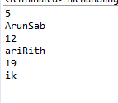

Rename method

import os as o;

o.renames(*'F:\\python\\name.txt'*, *'F:\\python\\rithik.txt'*)

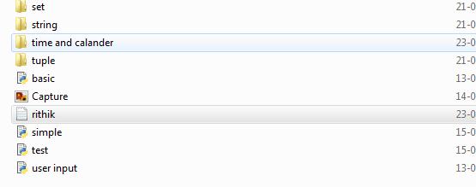

Remove method

import os as o;

o.remove(*'F:\\python\\rithik.txt'*)

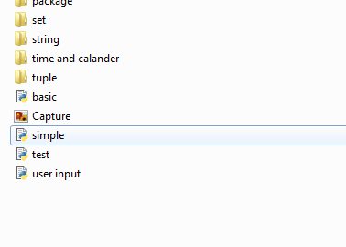

Make directory

import os as o;

o.mkdir(*'F:\\python\\Surya'*)

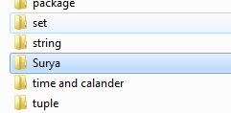

Remove directory

import os as o;

o.rmdir(*'F:\\python\\Surya'*,)



Get the path

import os as o;

print(o.getcwd())

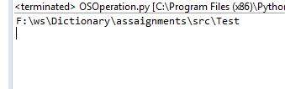

Change directory

Befor

import os as o;

f=open(*'name.txt'*,*'r'*)

f.seek(5)

print(f.tell())

print(f.read(7))

print(f.tell())

print(f.read(7))

print(f.tell())

print(f.read(7))

f.close()

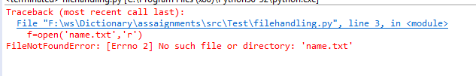

After change directory

import os as o;

o.chdir(*'F:\\python'*)

f=open(*'name.txt'*,*'r'*)

f.seek(5)

print(f.tell())

print(f.read(7))

print(f.tell())

print(f.read(7))

print(f.tell())

print(f.read(7))

f.close()

